Title of the thesis
Possible subtitle

Degree programme and study track
Master's thesis / Bachelor’s thesis
(Check the correct name of the degree programme and study track
in Sisu)

Author:
Firstname Lastname

Supervisor(s):
Title Firstname Lastname
Title Firstname Lastname

x.x.20xx
Helsinki

Title:
Author: Firstname Lastname
Month and year:
Number of pages:
Keywords:
Abstract:

Table of contents
1 Using the template 1
1.1 Cover 1
1.2 Abstract 1
1.3 Copying text to the template 1
2 Accessibility 2
2.1 How to draft an accessible document 2
2.2 Set a language for the document 3
2.3 Give the document a title 3
2.4 Check accessibility 3
3 Template settings and styles (Heading 1) 4
3.1 Template settings (Heading 2) 4
3.1.1 Template font (Heading 3) 4
3.1.2 Template page settings 4
3.1.3 Page numbers 4
3.2 Template styles 5
3.2.1 Headings 6
3.2.2 Normal text 6
3.3 Footnotes 6
3.4 Tables 6
3.4.1 Table formatting 6
3.4.2 Add a table and a header row 7
3.4.3 Add heading to the table 7
3.4.4 Add caption text to the table 8
3.5 Figures and pictures 9
3.5.1 Add picture 9
3.5.2 Accessibility and alternative texts for figures and pictures 10
3.5.3 How to write alternative text 11
3.5.4 How to add alternative text 11
3.6 Equations 12
3.7 Accessible Colours 12
3.8 Table of contents 13
3.8.1 How to add automatic table of contents 13
3.8.2 Add a table of pictures, figures or tables to the table of contents 13
3.9 Check the layout of completed thesis 13
References 15
Appendices 16
Appendix 1 Heading 16
Appendix 2 Heading 16

Using the template
This document is a template for theses and contains instructions for layout. Accessibility specifications for the document have been made at the University of Turku.

Cover
First page of the template is the cover page. Click on the text and add the required information.

Abstract
Style of the abstract is Abstract.
There can be several key words and they must be separated by a comma.

Copying text to the template
The template works best when the text is written directly into it, but it is also possible to copy-paste text from another document. However, there are issues in copy-pasting text that should be taken into consideration.
If you have used styles in the original document, they have to be deleted before copy-pasting the text. Highlight the text in the original document that you wish to copy-paste to the template. Select Clear All Formatting from the Font section on the Home tab. After doing this, you can copy the text to the template.
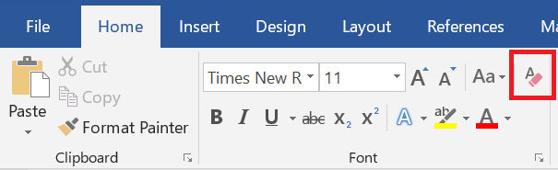
If you copy the entire document by selecting all (Ctrl + A), the header and footer as well as all other formatting will be copied. This will disrupt the settings in the template. Therefore, it is recommended that text, tables, and figures are copy-pasted to the template.

Accessibility
The Web Accessibility Directive of the European Union came into force on 23 September 2020. The Directive obligates the University of Helsinki to ensure that all the materials (text, photos, files, videos) shared on the University's public website are accessible. Also thesis files have to be accessible. Readiness to produce accessible contents is also an important professional life skill.
Accessibility refers to both intelligible contents and technical accessibility. A thesis is accessible when
- the author uses clear and intelligible language,
- it has a clear and logical structure,
- its layout is easy to read,
- it meets the requirements of technical accessibility.
You can ensure the accessibility of your file by using the text styles and instructions on this template. Once the word file is accessible, making an accessible PDF file is easy.

How to draft an accessible document
- Use different heading levels in a logical order (heading 1 > heading 2 > heading 3). Do not skip a level.
- Use the Word list tools as they clarify the structure and promote accessibility. If the list items do not have a clear order, use an unnumbered list style.
- Plan the structure and content of the document. Consider what serves the reader best: text, photo, list, or table.
- Do not add text to the file as an image. Avoid using floating text boxes as screen readers do not convert them correctly.
- Take care that the document looks clear. Use highlight formatting (cursive, bold, and underline) with careful consideration. Please note that underline is meant for links only.
- Remember to ensure the accessibility of tables and images (see chapters 3.4 and 3.5).

Set a language for the document
In the thesis template, the document language (Finnish/English) has been set beforehand. If the document contains content in a different language, you can set the correct language for these text parts: highlight the text that is in a different language > open the Review tab and click the Language icon > Set Proofing Language > set the language for the text.

Give the document a title
Give the document a title: open Info from the File tab > add the main title of the document as the title. Please note that the document title is not the same as file name.

Check accessibility
When your document is ready, check its accessibility: open Info from the File tab > select Check for Issues > select Check Accessibility > fix the parts that are not accessible.

Template settings and styles (Heading 1)
The first chapter of the thesis that is given a number is the introduction. All text chapters are numbered. References and appendices are not numbered.

Template settings (Heading 2)

Template font (Heading 3)
Two fonts are used in the template: Arial font is used in the headings. Arial is also used in the text in equations, figures, and pictures. The font used in text paragraphs is Georgia. When you use the styles of this template, the fonts and line spacing are set automatically.

Template page settings
The page settings in the template are:
- page size A4 (210 x 297mm)
- top and bottom margins 2.5cm
- left and right margins 2cm. If you print the thesis, ask the printing house how much space is needed for stitching and add it to the document.
In all the styles used in the template, the text is aligned to the left and the right margin is unjustified (ragged). Unjustified right margin improves the document’s accessibility.

Page numbers
The page numbering starts from the first textpage of the thesis. In the template, the page numbers appear in the top right-hand corner.
If you are using Word tools for drafting a table of contents, references, or a list of figures, pictures or appendices, remember to update the lists after completing the document (see chapter 3.8).

Template styles
Use the text styles in this template in all the text contents of your thesis. If you do not use these styles, the template does not function as designed. By using the styles, the letters, font size, and line spacing are automatically correct. This is important for the accessibility of the document. Do not change the style settings.
Styles used in the template:
- Abstract
- Body Text1
- Citation
- Figure caption text
- References
- Table caption text
- Table text
- Thesis footnote
- Title
- Heading 1
- Heading 2
- Heading 3
- TOC 1
- TOC 2
- TOC 3
- TOC Heading
The styles are paragraph-specific, i.e. the style applies to text between two hard returns. You can view the style of each paragraph in the styles panel at the top right-hand side of the Home tab. Change the style of the paragraph by clicking the correct place in the text and select Styles > select the correct style.
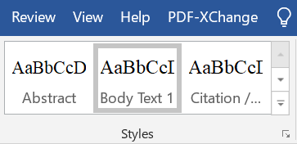

Headings
If you divide a chapter into subsections, there always has to be two. Use Heading 1 as the style for the heading of the whole chapter (X), use Heading 2 as the style of the second-level subsection heading (X.X), and Heading 3 in third-level subsection headings (X.X.X).
Do not add an empty row above or below headings.

Normal text
In the so-called body text paragraphs, the style is Body Text 1.
No empty rows are added between paragraphs.
Citation style is used in citations that are longer than two rows, and the right and left margins are indented. Indented citations do not have quotation marks.

Footnotes
If your thesis contains footnotes or endnotes, use the style Thesis footnote. Insert footnote: select References > select Insert Footnote or Insert Endnote.
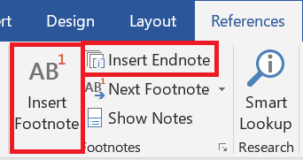

Tables

Table formatting
Place a large table on the same page whenever possible. Remember to add the header row (see instructions in the next subsection).
The tables have to be indented to the same level as the body text, so that the left-hand side of the table and text are aligned. They must not cross into the margin. However, if the table is so large that it will not fit on the page when indented, it has to be formatted by hand or centred.
If the table is wide, you can also consider turning the page so that it is horizontal. To do this, add section break from the Layout tab > Breaks > Next Page on the both sides of the table and change the orientation of the table page to horizontal from the Layout menu > Orientation. Avoid formatting where a thick line borders each cell of the table.

Add a table and a header row
Add a table by selecting Insert > Table. It is important for accessibility that you do not add the table to the document as a picture but create it with the table tools.
It is essential for accessibility that the table has a header row. Add a header row for your table: click the top row of the table and Table Tools becomes visible in the top panel. Select Layout > select Repeat Header Rows. This way, the header row is repeated if the table is divided to multiple pages.
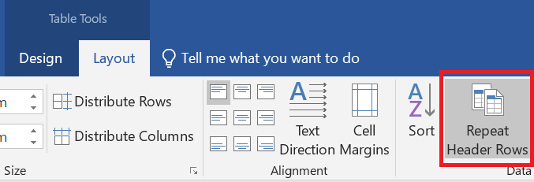
Avoid using merged cells. Finally, make sure that the contents are in the correct order in the table columns: put the cursor in the first cell of the table and move from one cell to the next with the tabulator key.

Add heading to the table
All tables are given a heading. The heading is placed above the table
Create a heading for the table: place the cursor on top of the table and right-click the icon that appears in the left top corner > select Insert Caption > select Table as the Label > add the heading. Leave Table X as an identifier to the beginning > select Above Selected Item from Position.
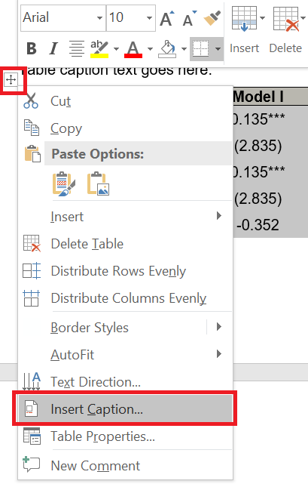
Finally, make sure that you have used Table caption style in the table heading and Table text style in the table text.

Add caption text to the table
The table should be understandable without the reader having to read other text. However, if the table needs a caption text to support understanding, you can add it between the heading and the table itself. The style is Table caption text. In the table cation text, you can, for example, explain the entries in the table for the part that you can assume they are unfamiliar to the reader.

Table 1. Heading
Table caption text goes here.
 | Model I | Model II | Model III
Constant | 0.135*** | 0.135** | 0.150**
 | (2.835) | (2.135) | (2.035)
Variable 1 | 0.135*** |  | 0.005***
 | (2.835) |  | (3.135)
Variable 2 | -0.352 | 0.135**
 | (-1.135) | (2.835)
In total | 10.567% | 12.570% | 8.057%

Figures and pictures

Add picture
All figures and pictures are given a heading and a number. The numbering is automatic. Caption is below the figure or picture.
Add a heading to the figure or picture: right-click the figure or picture > Insert Caption > select Figure from Label > add the heading. In the same pane, select Below Selected Object in Position.
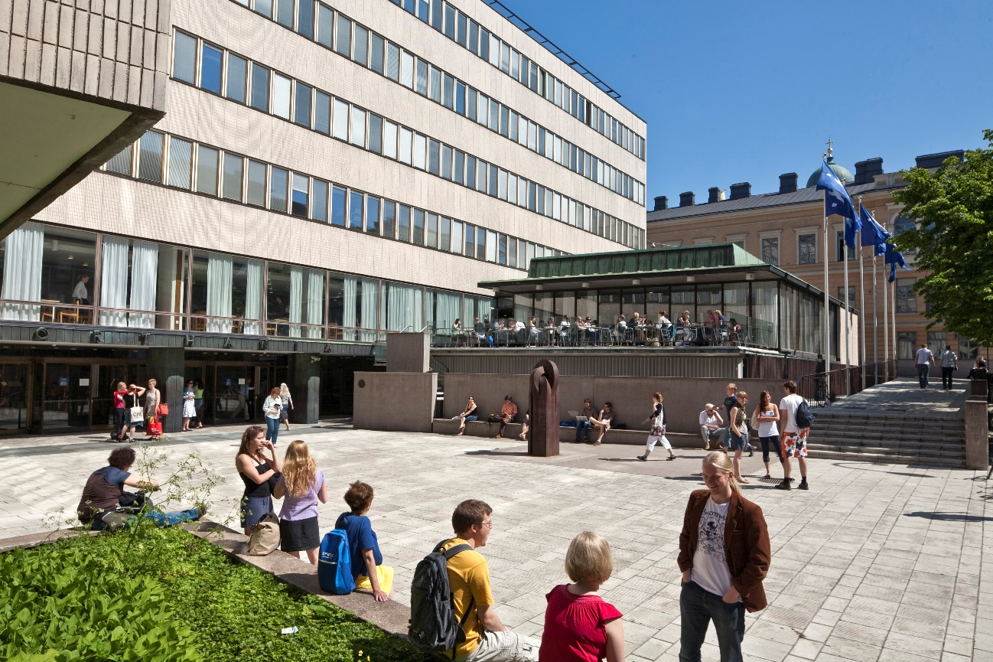
Picture 1. With figures and pictures, the caption is placed below the element. Keep the captions short and informative. The style of the captions is Figure caption. Please note that you have to have the right to use the picture and the name of the photographer/author has to be included. Picture: Firstname Lastname.
Figures have to be indented to the same level as the body text so that the left-hand side of the figure and the text are aligned. They must not cross into the margin. However, if the table is so large that it will not fit on the page when indented, it has to be formatted by hand or centred.
Remember that you have to refer to each table, figure, and picture in the text. The reference has to be near the element. You do not have to mention the location of the figure in the reference. In English, refer to tables, figures, and pictures with a capital letter: this can be seen from Figure 1.

Accessibility and alternative texts for figures and pictures
Use only pictures that are significant to the contents of the thesis.
To ensure accessibility, all non-textual content (figures, pictures) must have an alternative text. Alternative text is also referred to as alt text. It is important that a reader who cannot see the figure or picture gets the same information as a reader who can see it.
In principle, alternative text is added to all figures and pictures. When writing the alternative text, think about what information is left out if you cannot see the figure or picture. Focus on the essential matters in the alternative text, do not write excessively long descriptions.
Caption is not repeated as such in the alternative text, as the screen reader reads both the caption and the alternative text. If the alternative text is missing, the screen reader reads the name of the image file.
The alternative text is added in the same language as the document.
In order for alternative texts to be genuinely useful for users, the function of the image and the surrounding text must be taken into consideration when writing the alt text. When writing an alt text, pause to consider the answer to following questions:
- What information is left out without the image?
- What is the purpose of the image in its location?
- Have the contents of the image been told in the surrounding text?

How to write alternative text
- Write as sharply and clearly as possible.
- Always end the alt text with a full stop.
- Do not start the alternative text with words "Picture" or "In the picture". Screen readers recognise images and notify the user of them.
- Write a neutral description, avoid interpretations.
- If the contents of the image are explained in the surrounding text, the alternative text only briefly describes the topic of the picture and mentions that the details of the picture are included in the text.
- The alternative text for figures is a focused summary of the key features of the figure, in case they are not otherwise explained in the surrounding text.

How to add alternative text
Move the cursor on top of the image and right-click it > select Edit Alt Text > add the alternative text for the figure or picture.

Equations
Presenting equations is very important in some fields. You can add equations by clicking Insert > Equation.
You can centre the equation by selecting a tab for the equation row which is centred: select Center Tab > click the equation > add the tab to the 8cm mark by clicking the ruler at the top of the page. Finally, add a tab in front of the equation so that it is centred.
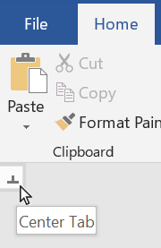
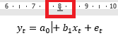
The equations can also be numbered. If you want to add the number to right hand side of the equation (like in the picture below), add Right Tab to the right side of the row and add tab after the equation. Add the number of the equation. After the equation, the sentence continues as if it has not been interrupted.
$y_{t}=a_{0}+b_{1}x_{t}+e_{t}$ (1)

If the equation has several variables, you can make a list out of them. Usually, the variables are in cursive in the text and vectors/matrices are in bold.

Accessible Colours
Take possible readers with visual impairments or colour vision deficiencies into account when using colours.
- Use basic colours that are distinguishable
- Use required contrast ration
- Make sure that the meaning of content is not presented only with colours
- The meaning of content should not be affected if colours are removed

Table of contents
The table of contents is set automatically in the template. When you use the styles correctly, the program drafts the table of contents on the basis of the document headings. Remember to update the table of contents: right-click it with the mouse > select Update Field > select Update Entire Table from the pop-up window.
If you notice any errors in the table of contents, press the Ctrl key and click on the row with the mistake. The cursor will automatically move to the spot in question in the document. Check which style is used and change it if necessary. You can change the style when the cursor is on the correct row and by selecting the correct style from the Styles selection. If headings are missing from the table of contents, check the style of the missing heading and change it as described above. Finally, update the table of contents.

How to add automatic table of contents
Move the cursor to where you want to create the table of contents. Open References tab > select Table of Contents > select Custom Table of Contents from the bottom > select From template from Formats and further select None from the Tab Leader drop down menu > click ok.

Add a table of pictures, figures or tables to the table of contents
Move the cursor to where you want to create the table of contents. Open References tab > click Insert Table of Figures > select Figure/Table from the Caption Label panel > select Classic from Format panel > Select None from the Tab Leader drop-down menu > ensure that all the boxes are ticked > click ok.

Check the layout of completed thesis
- Finally, check that all the headings are visible in the table of contents. Update the table of contents.
- Check that the heading and the following paragraph are on the same page. If necessary, you can make a form feed (Ctrl+Enter).
- You can view line and form feeds by clicking the Show/Hide ¶ icon in the Paragraph section of the Home tab. You can hide the marks by clicking the same icon. Line feeds are shown as the ¶ mark. Finally, delete the extra line feeds.
- Make sure that all the sources are listed in the references.
- Update the figure, table and picture lists if you have used them.
- Delete the extra pages.
- Check the accessibility of your thesis (see chapter 2.4).
- Create an accessible PDF file in accordance with the instructions for students.

References
References are grouped and marked according to the practices in your field/subject. The style is References.
References begin from a new page. The section is not numbered.

Appendices
The main heading of the appendices is not numbered. The same styles are used in the appendices as in the text chapters.

Appendix 1 Heading
Each appendix is numbered and given a heading.

Appendix 2 Heading
You can start each appendix from a new page if you wish.

The number of the footnote appears by default after the punctuation mark in the sentence, but if the footnote is related to the preceding word, the footnote can be added after the word.

